Certificate of Exemption - AGAR 2024/25 Form 2
To be completed by smaller authorities where the higher of gross income or gross expenditure did not exceed E25,000 in the year of account ended 31 March 2025, and that wish to certify themselves as exempt from a limited assurance review under Section 9 or the Local Audit (Smaller Authorities) Regulations 2015
There is no requirement to have a limited assurance review or to submit an Annual Governance and Accountability Return to the external auditor, provided that the authority has certified itself as exempt at meeting Of the authority after 31 March 2025 and a completed Certificate of Exemption is Submitted no later than 30 June 2025 notifying the external auditor
certifies that during the financial year 2024/25, the higher of the authority's total gross income for the year or total gross annual expenditure, for the year did not exceed €25,000
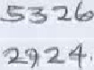
Total annual gross income for the authority 2024/25:
Total annual gross expenditure for the authority 2024/25:
There are certain circumstances in which an authority will be unable to certify itself as exempt, so that a limited assurance review will still be required, Il an authority is unable to confirm the statements below then it cannot certify itself as exempt and it must submit the completed Annual Governance and Accountability Return Form 3 to the external auditor to undertake a limited assurance review for which a fee of £210 +VAT will be payable.
By signing this Certificate of Exemption you are confirming that:
- The authority was in existence on 1st April 2021
- In relation to the preceding financial year (2023/24h the external auditor has not:
- issued a public interest report in respect of the authority or any entity connected with it
- made a statutory recommendation to the authority. relating to the authority or any entity connected with it
- issued an advisory notice under paragraph f(l) of Schedule g to the Local Audit and Accountability Act 2014 ("the Act"), and has not withdrawn the notice
- commenced judicial review proceedings under section 3 I(l) of the Act
- made an application under section 2811 i of the Act for a declaration that an item of account is unlawful, and the application has not been withdrawn nor has court to make the declaration
- The court has not declared an item of account unlawful after a person made an appeal under section
If the above statements apply and the authority neither received gross income. nor incurred gross expenditure, excoed.ng then the Certificate or Exemption can be signed and a copy submitted to the external auditor either by email or by post (not both).
The Annual Internal Audit Report, Annual Governance Statement. Accounting Statements, an analysis Of variances and the reconciliation plus the information required by Regulation 15 Accounts and Audit Regulations 2015 including (he period for the exercise of public rights still need to be fully completed and, along with copy 01 this certificate. published on the authority website/web page• before 1st July 2025. Signing this certificate confirms the authority will comply with the publication requirements,
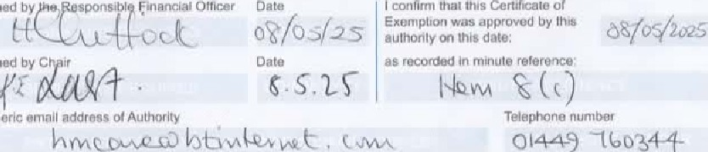

'Published web address
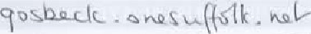
ONLY this Certificate of Exemption should be returned EITHER by email OR by post (not both) as soon as possible after certification to your external auditor, but no later than 30 June 2025. Reminder letters for late submission will incur a charge of £40 + VAT.
Page 3 of 6

